**PROJECT REPORT**

PROJECT REPORT ON **HANGMAN GAME**

**Problem Statement:** Hangman Game is a game for two or more players where one player thinks of a word, phrase orsentence and others have to guess it by suggesting letters or numbers within a certain number of guesses. If the guesses are right then the guesser wins the game. Else for each incorrect guess, the other player draws one element of a hanged man stick figure as a tally mark and when the hanged man is complete, the opponent loses. *The game is over when the guessing player completes the word, or guesses the whole word correctly.*

**Report:** In my project, a single player plays the game and the rules are strictly followed by the program. After running the project, it will work like the following images:-

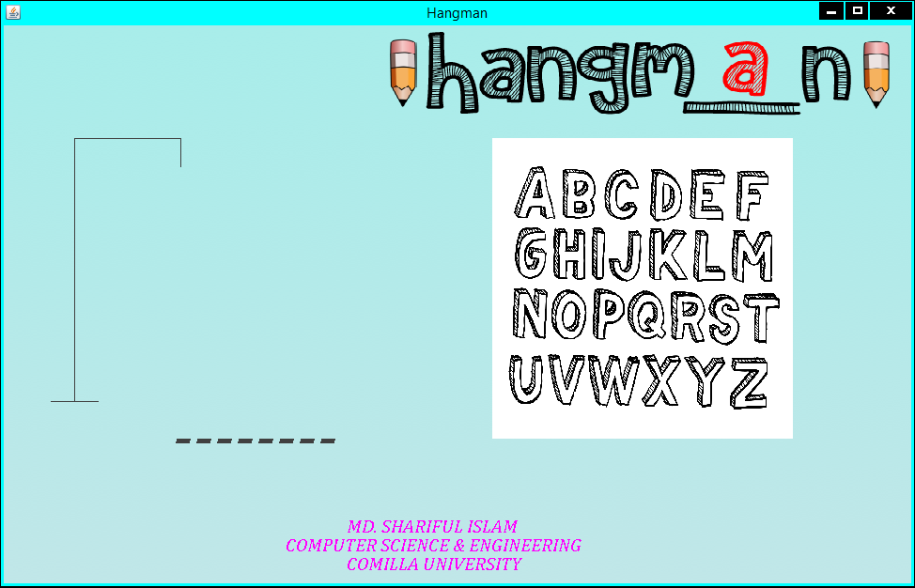

**Figure 1 : Game Start**

Figure 1 will appear after running the Hangman Game project. In the figure, it shows that a word of 8 characters have to be guessed.

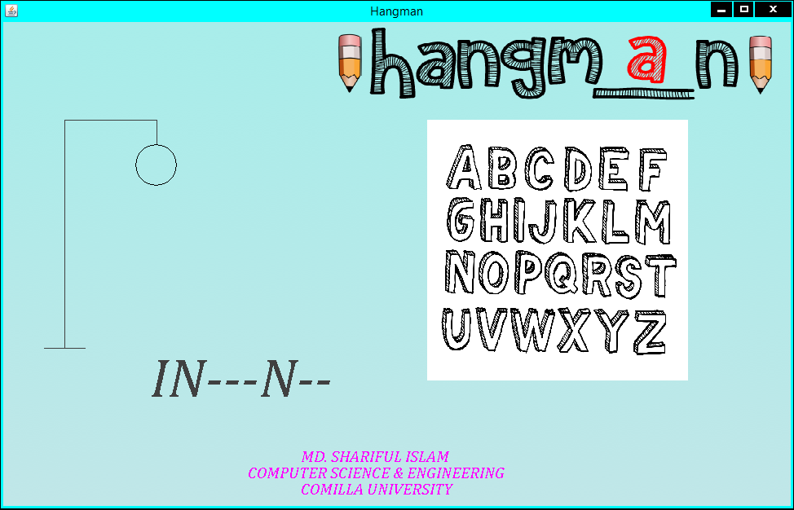

**Figure 2 : After guessing a wrong letter**

Figure 2 shows that, if the player guess a wrong letter than it will start to draw a figure and it will start the drawing with a circle which denotes the head of the hangman.

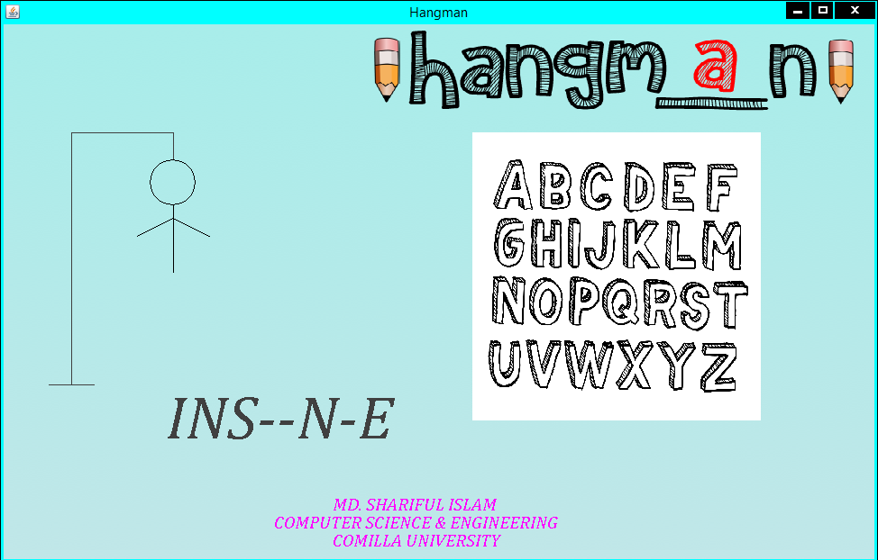

**Figure 3 : After guessing more wrong letters**

Figure 3 shows the condition after guessing more than one wrong letters. If the process is continued and man is completed before finding the correct word then the game will be over.

A player at most can choose six wrong letters. That means he has 6 lives to complete the game.

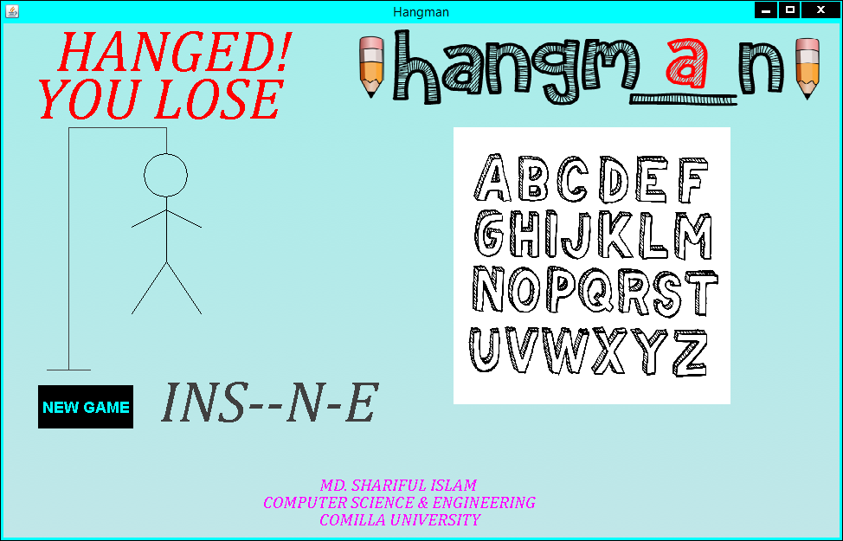

**Figure 4 : Game Over**

Figure 4 shows that the man is hanged and the game is over after six wrong guesses. Later the player can press the “NEW GAME” button showed in the lower left corner of the image if he wants to play the game again.

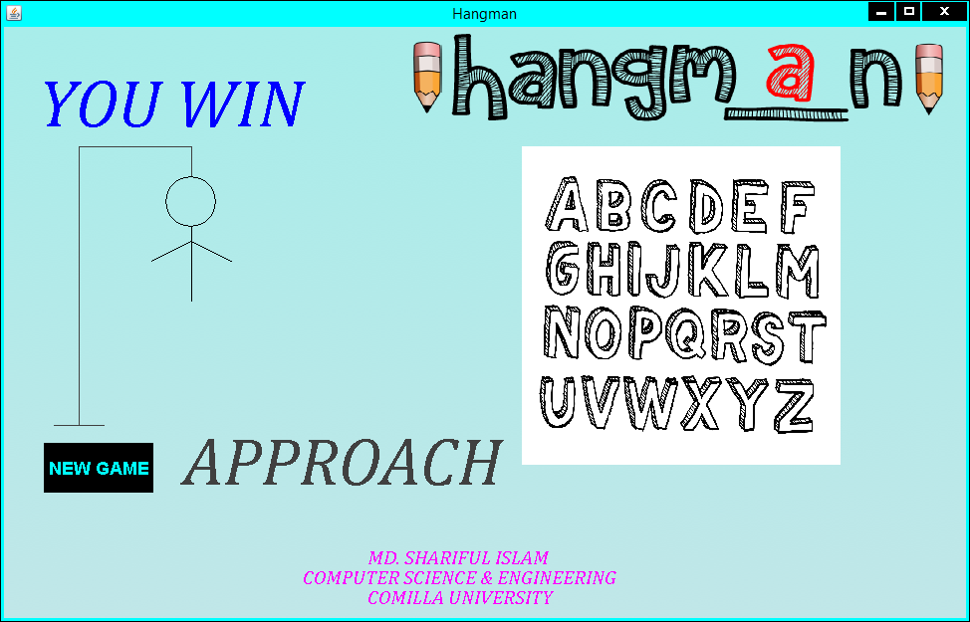

**Figure 5 : After guessing the right word**

In the above figure, we can see that the winning moment of the game. Here the player guessed the right word after four wrong guesses. Later the player can press the “NEW GAME” button showed in the lower left corner of the image if he wants to play the game again.

Hence the project is worked.

*GitHub Link:*

GitHub-Mark-32px.png https://github.com/SharifulCSECoU/MY_Projects/blob/master/JAVA/HangmanGame.rar

*Reference:*

The reference I took for hangman coding to make the project more understandable for human language are given below:-

https://www.youtube.com/user/Redemptie

https://www.dropbox.com/s/qp9ve8qny5aza92/Hangman%20Code.zip?dl=0

https://webgradients.com/public/webgradients_png/023%20Rare%20Wind.png

http://www.roomrecess.com/mobile/Hangman/img/HangmanTitle.png

http://www.onlygfx.com/wp-content/uploads/2018/10/hand-drawn-3d-alphabet-cover.png